## Name: GARDAS,Nuthan ID:20643274

As the data has lot of keywords which can be marked as important, can be used to derive certain text data visualizations.

1. As these text data can be used to derive a sentiment, the major keywords can be used as word-map with size being the largest occurrence and the colour of it being red-for not agreeing and green for agreeing and yellow for neutral, the highest counts will be considered the primary colour.

2. For a person, the following visualization can be used

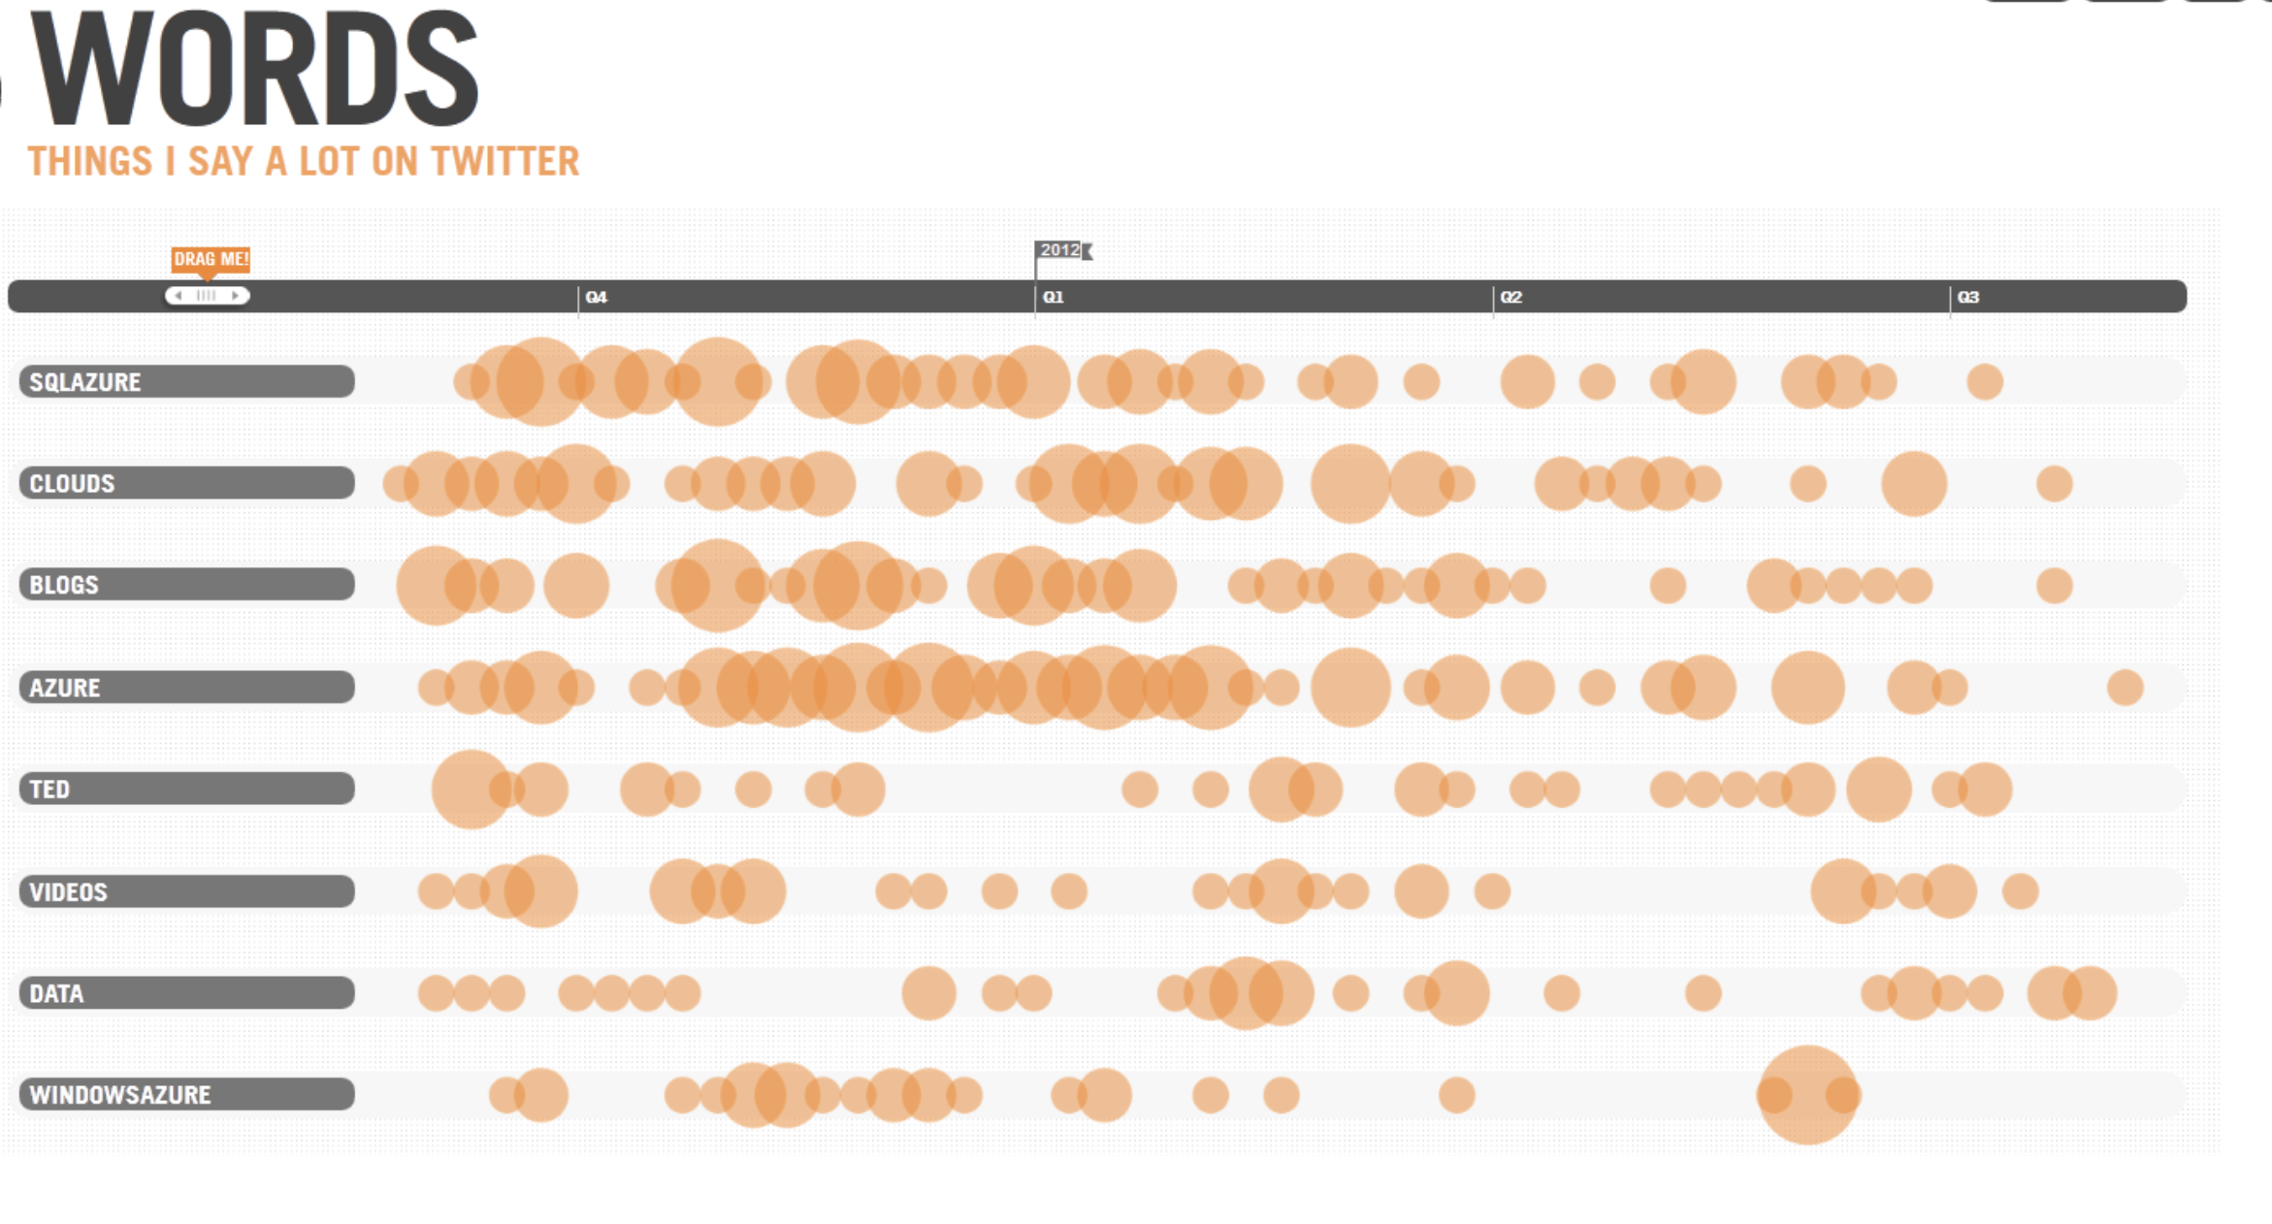

Where the occurence of words will be related to the size of the circle and the colour changes the sentiment of the user, this is just as an example.

3. The keyword summary can be produced as a graph visualization with nodes being the main nodes and the corresponding words to be the adjacent ones.